Assignment for Continuous Random Variables

1. It is Saturday morning at Starbucks. Is each random variable discrete (D) or continuous (C)？
a. Temperature of the coffee served to a randomly chosen customer.
b. Number of customers who order only coffee with no food.
c. Waiting time before a randomly chosen customer is handed the order.

Solution: a: continuous, b: discrete, c: continuous

2. Which of the following could not be probability density functions for a continuous random variable? Explain. Hint: Find the area under the function f (x).
Solution: a. and c. could not be probability density functions for a continuous random since the total area under the curve f(x) is not equal to 1.

3. Customers experiencing technical difficulty with their internet cable hookup may call an 800 number for technical support. It takes the technical between 30 seconds and 10 minutes to resolve the problem. The distribution of this support time follows the uniform distribution.
a. What are the values for end points of the uniform distribution (in minutes)?
b. what is the mean time to resolve the problem? What is the standard deviation of the time?
c. What is the probability of taking more than 5 minutes to resolve problems?
d. Suppose we wish to find the middle 50 percent of the problem-solving times. What are the end points of these two times?

Solution:
a. End points are: c = 0.5, d = 10.0 (using minutes as the units)
b. Mean is 5.25, found by (0.5 + 10)/2
Standard deviation is 2.74, found by
c. 0.5263, found by [1/(10 – 0.5)]*(10 – 5)
d. 2.875, found from [1/(10 – 0.5)]*(x – 5) = 0.25 and 7.625 found from [1/(10 – 0.5)]*(10 – x) = 0.25

4. According to the Insurance Institute of America, a family spends between $400 and $3,800 per year on all types of insurance. Suppose the money spent is uniformly distributed between these amounts.
a. What is the mean amount spent on insurance?
b. What is the standard deviation of the amount spent?
c. If we select a family at random, what is the probability they spend less than $2,000 per year on insurance per year?
d. What is the probability a family spends more than $3,000 per year?
e. What is the probability a family spends between $1500 and $2500?
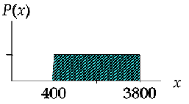
- The mean is given by

b. The standard deviation is given by

c. The probability they spend less than $2,000 per year on insurance per year is given by

d. The probability a family spends more than $3,000 per year is given by

e. The probability a family spends between $1500 and $2500 is

5. The distribution of weekly incomes of shift foremen in the glass industry follows the normal distribution, with a mean of $1000 and a standard deviation of $100. What is the probability of selecting a shift foreman in the glass industry whose income is:
1. Between $790 and $1000?
2. Less than $790?

Solution: Let x be the random variable of weekly incomes
2.

6. The amounts of money requested on home loan applications at down River Federal Savings follow the normal distribution, with a mean of $70,000 and a standard deviation of $20,000. A loan application is received this morning. What is the probability?
a. The amount requested is $80,000 or more?
b. The amount requested is between $65,000 and $80,000?
c. The amount requested is $65,000 or more?
Solution:
- The probability that the amount requested is $80,000 or more is

- The probability that the amount requested is between $65,000 and $80,000 is given by

- The probability that the amount requested is $65,000 or more is given by

7. The Layton Tire and Rubber Company wishes to set a minimum mileage guarantee on its new MX100 tire. Tests reveal the mean mileage is 67,900 with a standard deviation of 2,050 miles and the distribution of miles follows the normal distribution. They want to set the minimum guaranteed mileage so that no more than 4 percent of the tires will have to be replaced. What minimum guaranteed mileage should Layton announced?

Solution:
The fact of this case is shown in the following diagram, where k represents the minimum guaranteed mileage.
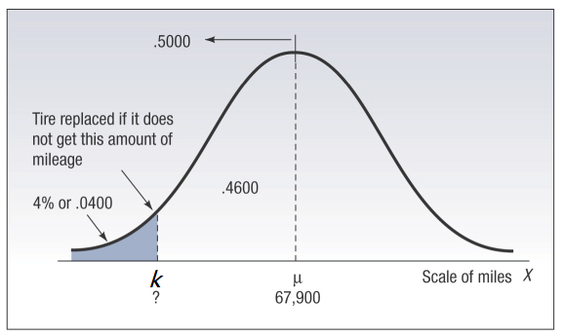
So we have
8. Weekly demand at a grocery store for a brand of breakfast cereal is normally distributed with a mean of 800 boxes and a standard deviation of 75 boxes.
a. what is the probability that weekly demand is
(1) 959 boxes or less?
(2) More than 1004 boxes?
(3) Less than 650 boxes or greater than 950 boxes?
b. The store orders cereal from a distributor weekly. How many boxes should the store order for a week to have only a 2.5 percent chance of running short of this brand of cereal during the week?

Solution:
- (1) P(x ≤ 959) = P(z ≤ 2.12) = .5 + .4830 = .9830 OR
Using Cum. Normal Table P(z ≤ 2.12) = .9830
(2) P(x > 1004) = P(z > 2.72) = .5 – .4967 = .0033 OR
Using Cum. Normal Table P(z > 2.72) = 1 – .9967 = .0033
(3) P(x < 650) + P(x > 950) = P(z < –2) + P(z > 2) = 2(.0228) = .0456 OR
Using Cum. Normal Table P(z < –2) + P(z > 2) = .0228 + (1 – .9772) = .0456
- P(x > 947) = P(z > 1.96) = .025
order = 947 boxes of cereal

9. | The binomial random variable x consists of n = 60 trials and has the probability of failure q = 0.4. Using the normal approximation, compute the probability of 32 successes.  Solution: µ = np = (60)(.6) = 36  σ = √(n)(p)(q) = √(36)(.4) = √14.4 = 3.795  P(31.5 ≤ x ≤ 32.5) = P(-1.186 ≤ z ≤ -0.9223) = .0618

10. In order to gain additional information about respondents, some marketing researchers have used ultraviolet ink to precode questionnaires that promise confidentiality to respondents. Of 205 randomly selected marketing researchers who participated in an actual survey, 117 said that they disapprove of this practice. Suppose that, before the survey was taken, a marketing manager claimed that at least 65% of all marketing researchers would disapprove of the practice.
a) Assuming that the manager’s claim is correct, calculate the probability that 117 or fewer of 205 randomly selected marketing researchers would disapprove of the practice. Use the normal approximation to binomial.
b) Based on your result of part a, do you believe the marketing manager’s claim?

Solution:
a.
, rounding z to 2 decimal places gives .010
b. No

